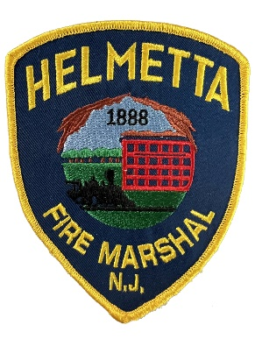 | BOROUGH OF HELMETTA  BUREAU OF FIRE PREVENTION  OFFICE OF CODE ENFORCEMENT  51 Main Street Helmetta, NJ 08828  Office: (732) 521-4946 ext. 109 | 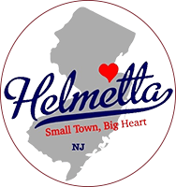
George Wallace – Fire Marshal

BUREAU OF FIRE PREVENTION

UNIFORM FIRE CODE N.J.A.C. 5:70-2.3
SMOKE DETECTORS, CARBON MONOXIDE ALARMS, FIRE EXTINGUISHERS

Under the Uniform Fire Code of the State of New Jersey, all persons who sell, rent or transfer ownership of a residence - home, townhouse, condo, apartment, must have a smoke detector, carbon monoxide detector, and fire extinguisher compliance test performed before the closing is executed.

N.J.S.A. 52:27D-198.1 RESIDENTIAL STRUCTURES TO HAVE SMOKE SENSITIVE ALARM DEVICES, PORTABLE FIRE EXTINGUISHERS.

Before any Use Group R:3 structure is sold, leased, or otherwise made subject to a change of occupancy for residential purposes, the owner shall obtain a certificate of smoke detector and carbon monoxide (CSDCMAC) evidencing compliance with N.J.A.C. 5:70 4:19, from the appropriate enforcing agency.

In accordance with N. J. A. C. 5:70-2.3(a) the owner or authorized agent of the owner shall apply for a CSDCMAC on a form provided by the enforcing agency. The application shall be accompanied with the appropriate fee. Completed applications should be submitted in a timely manner at least seven (7) days in advance of requested date of inspection.

Any questions, comments, concerns and to schedule an appointment Please contact the Bureau of Fire Prevention at (732) 521-4946 ext: 109

